**Azure DevOps – Azure Repos**

**Topics:**

1. **Git commands**
2. **Connecting Azure repos to local storage or to VS Code**
3. **Creating pipelines in Azure DevOps**
4. **Linking Azure DevOps with Azure DataBricks**

TVFC – previously Azure DevOps had this VCS (version control system)

VCS:

1. Distributed
2. Centralized

Refer all **git bash commands** in another file uploaded by me (my git file drive link):

[**https://docs.google.com/document/d/1UMUAz-U72NLdYty-GYH2Ly-7Uz7GVp8t/edit?usp=drive_link&ouid=115068786868801780046&rtpof=true&sd=true**](https://docs.google.com/document/d/1UMUAz-U72NLdYty-GYH2Ly-7Uz7GVp8t/edit?usp=drive_link&ouid=115068786868801780046&rtpof=true&sd=true)

**Repos created:**

Note: you can create multiple repos in one project

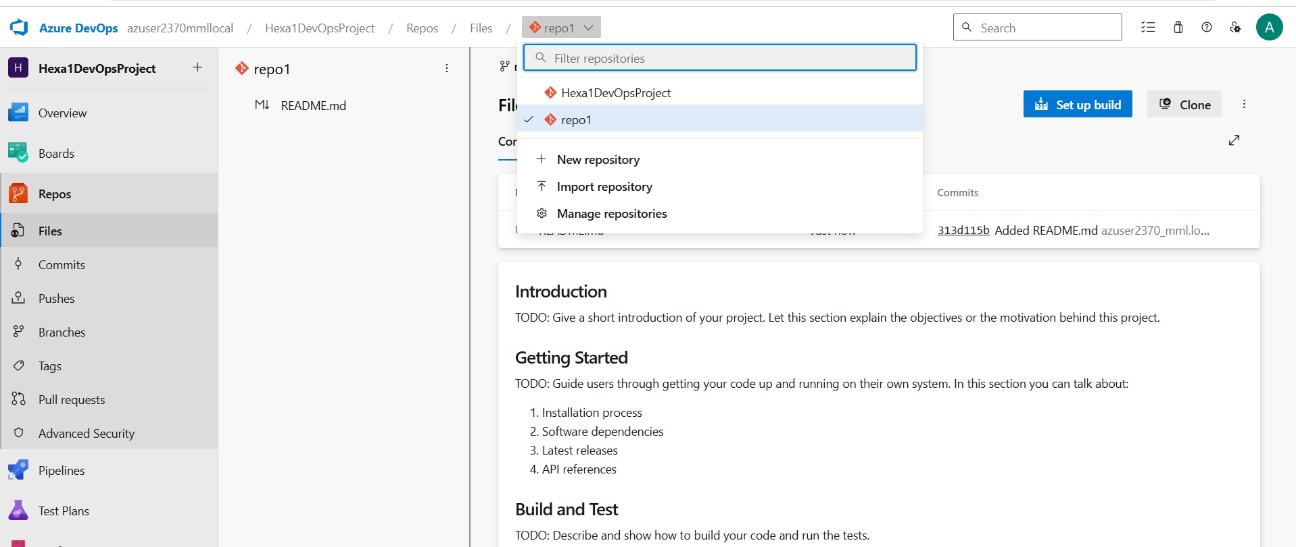

**Simple cloning of azure repo with the link (without configuring – hence it is not showing as main branch instead showing as master branch):**

[**https://learn.microsoft.com/en-us/azure/devops/user-guide/code-with-git?view=azure-devops**](https://learn.microsoft.com/en-us/azure/devops/user-guide/code-with-git?view=azure-devops)

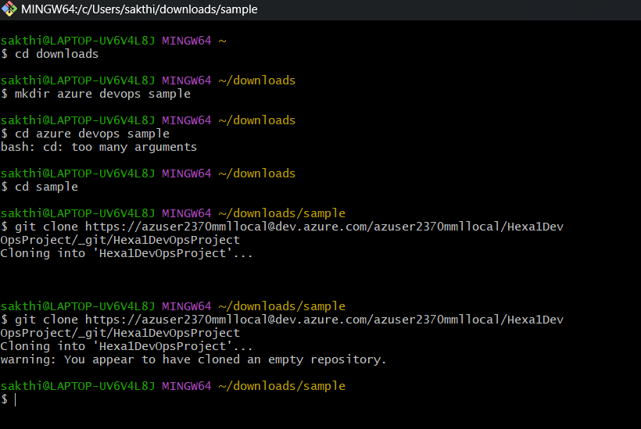

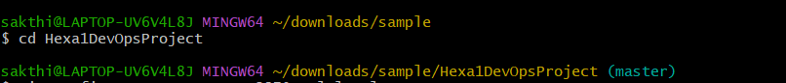

In main branch:

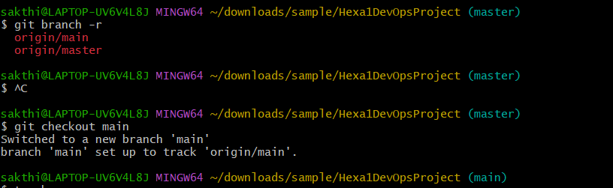

**Cloned successfully:**

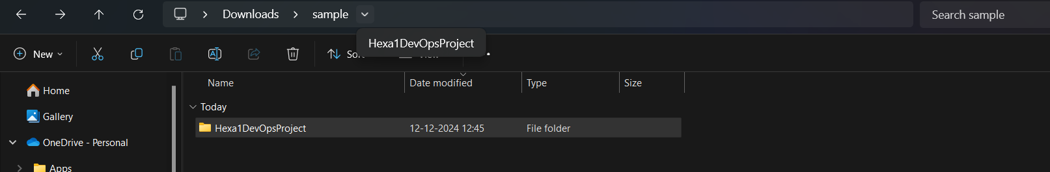

**Azure devops Piplines:**

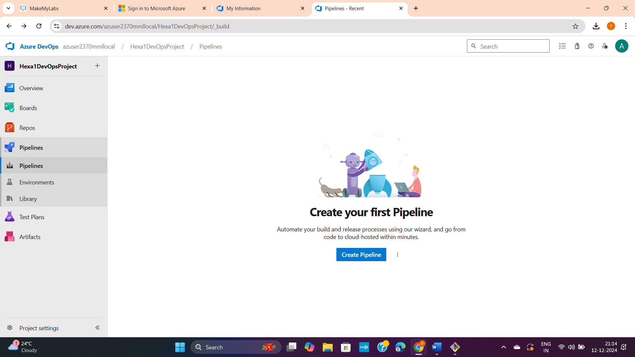

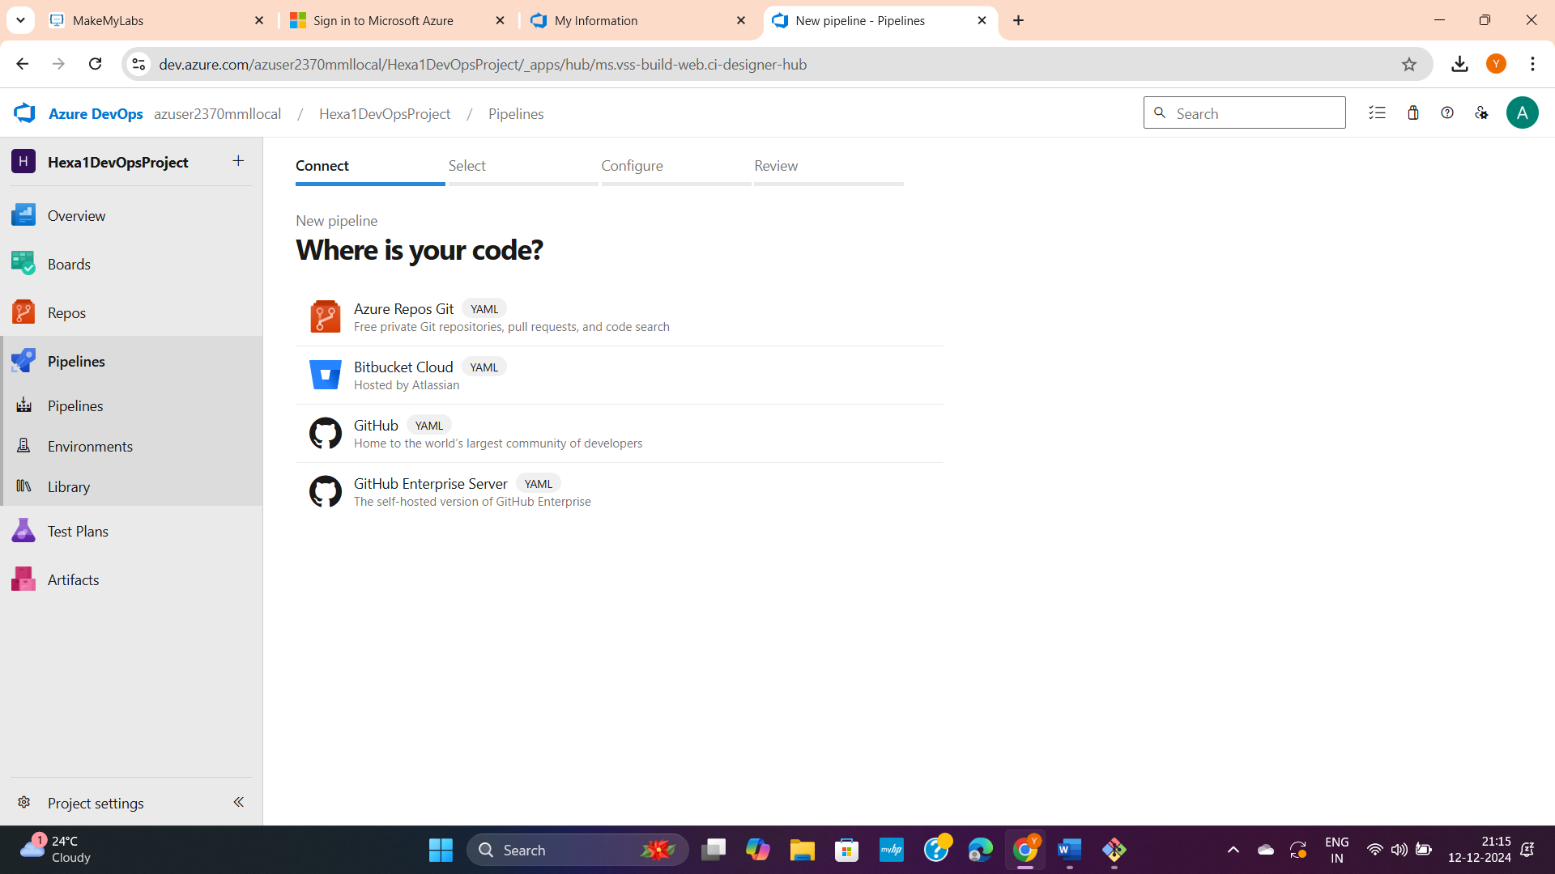

If you want click git or else just click the Azure Repos in above options and select any one repo you want.

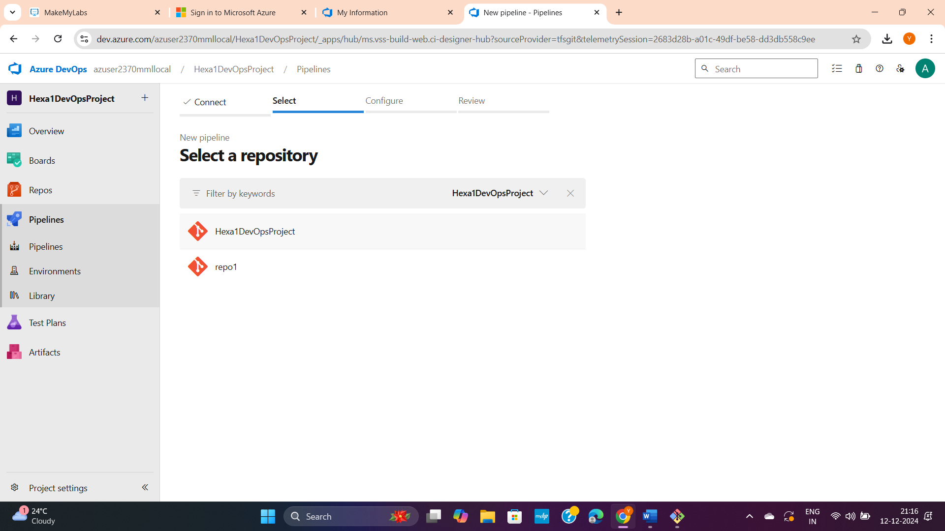

Click starter pipeline (below)

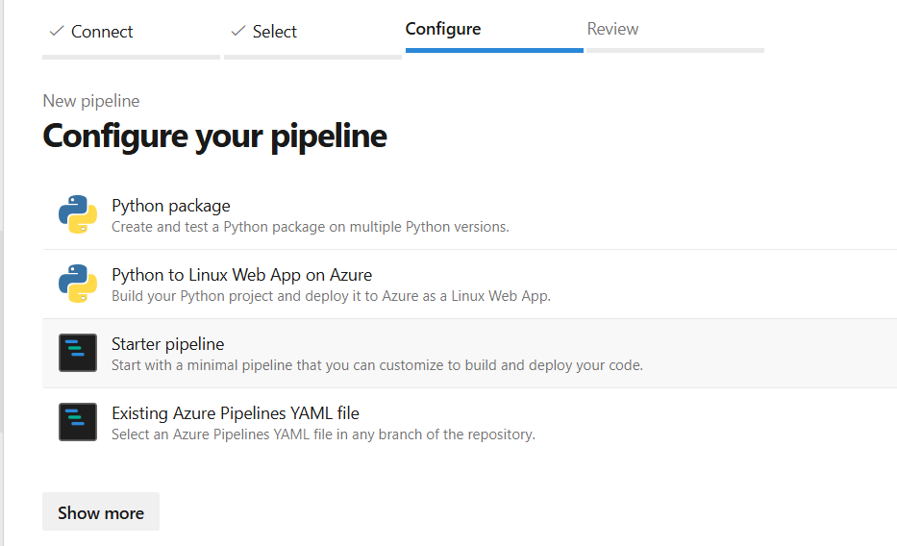

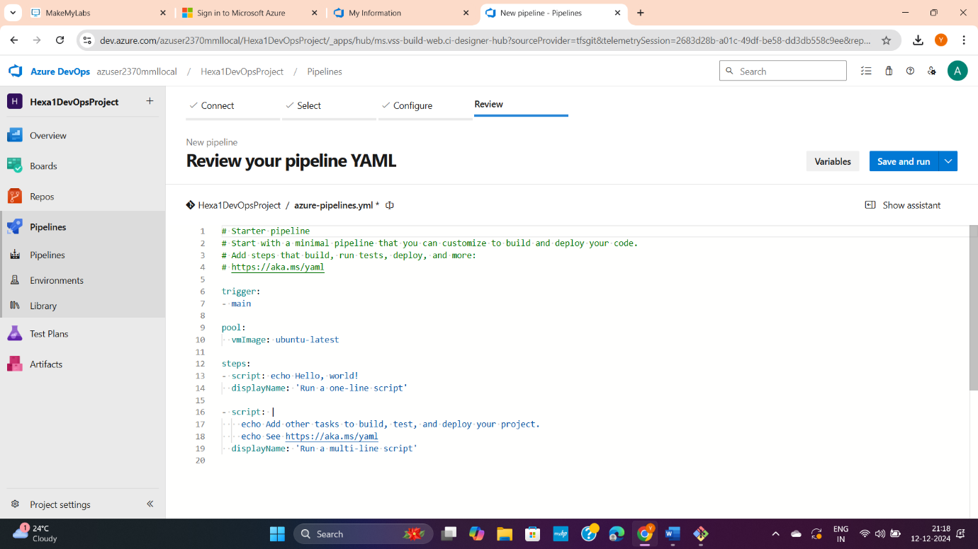

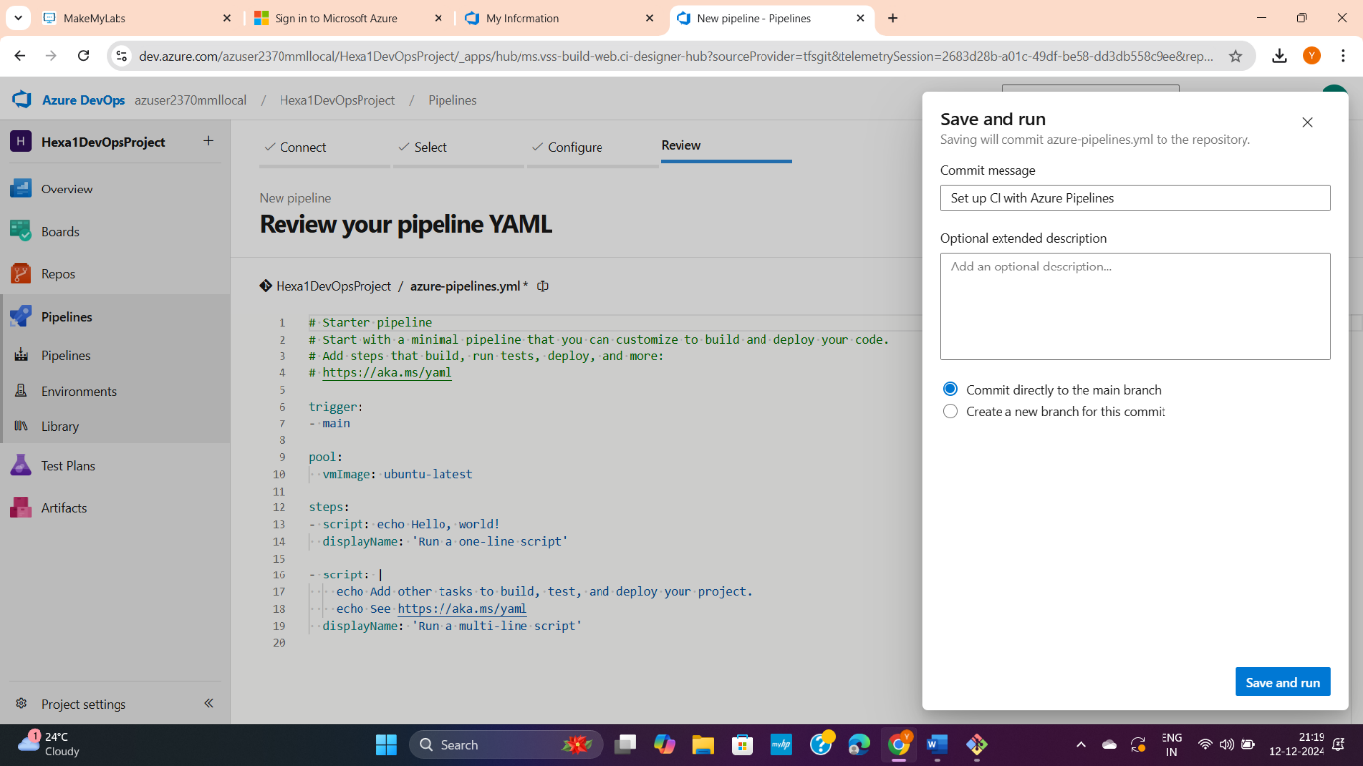

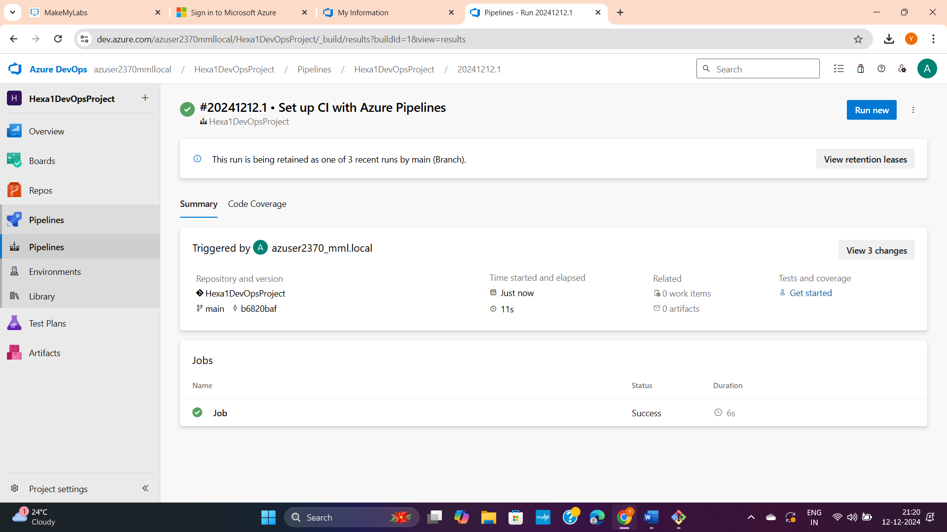

**Linking Azure DevOps with Azure DataBricks:**

Goto Azure devops >> user settings>> securt>> pesonel access tockens >> new tocken

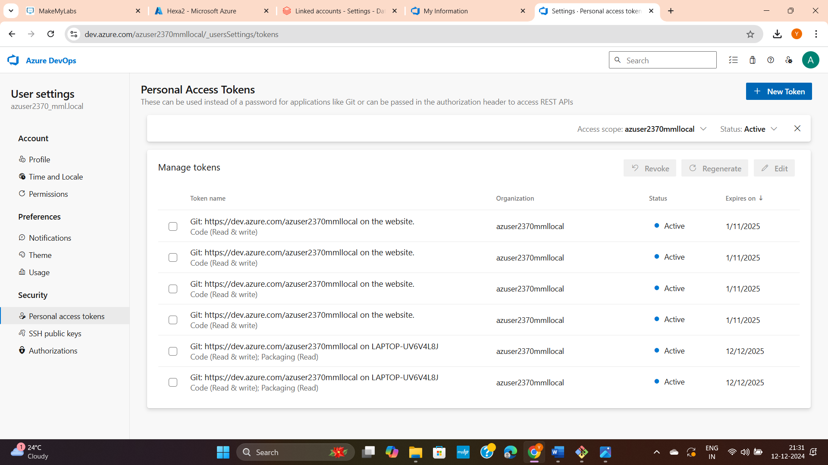

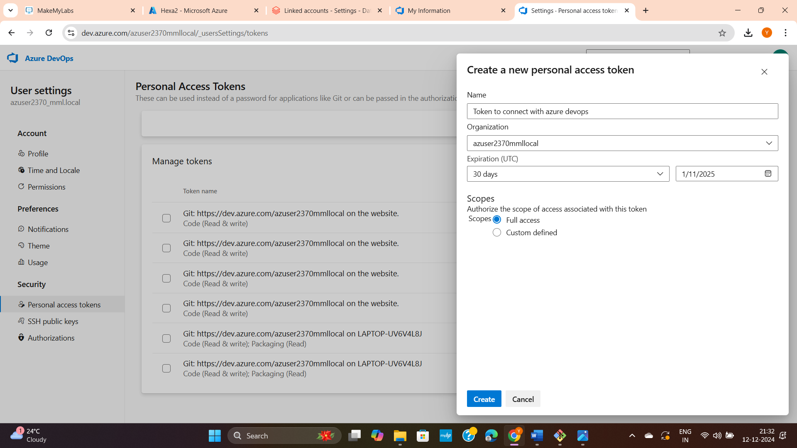

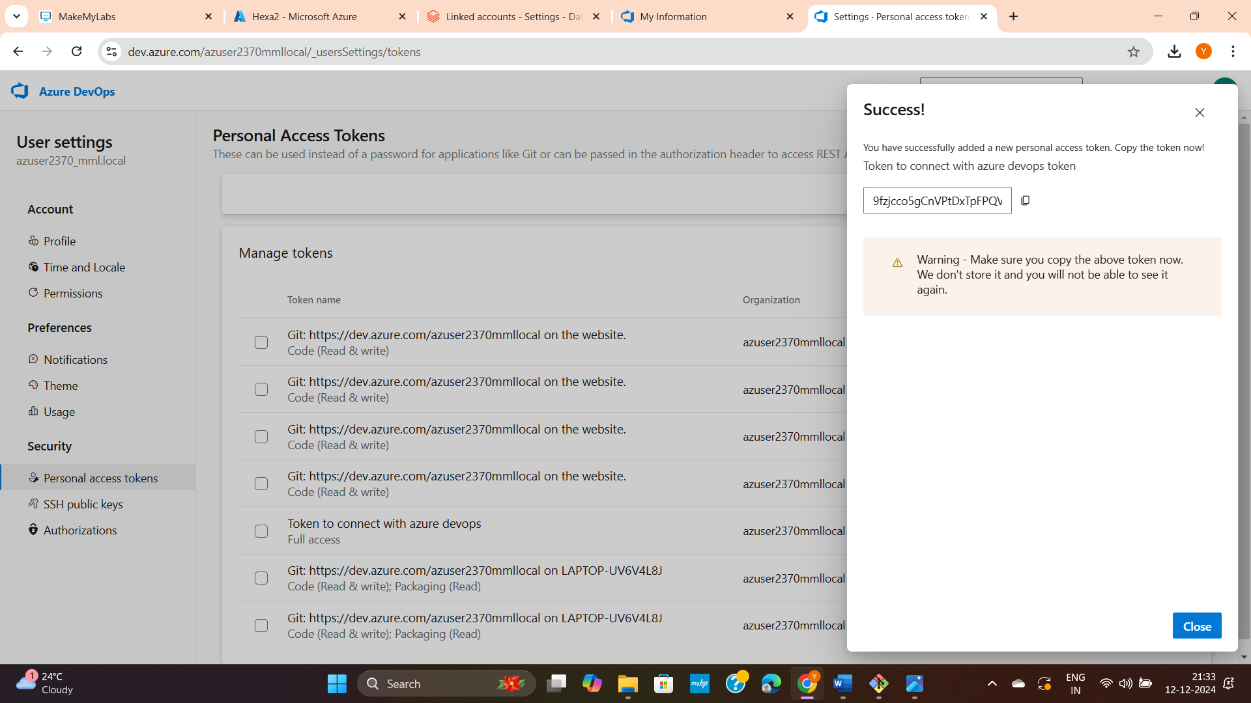

Goto Azure DataBricks

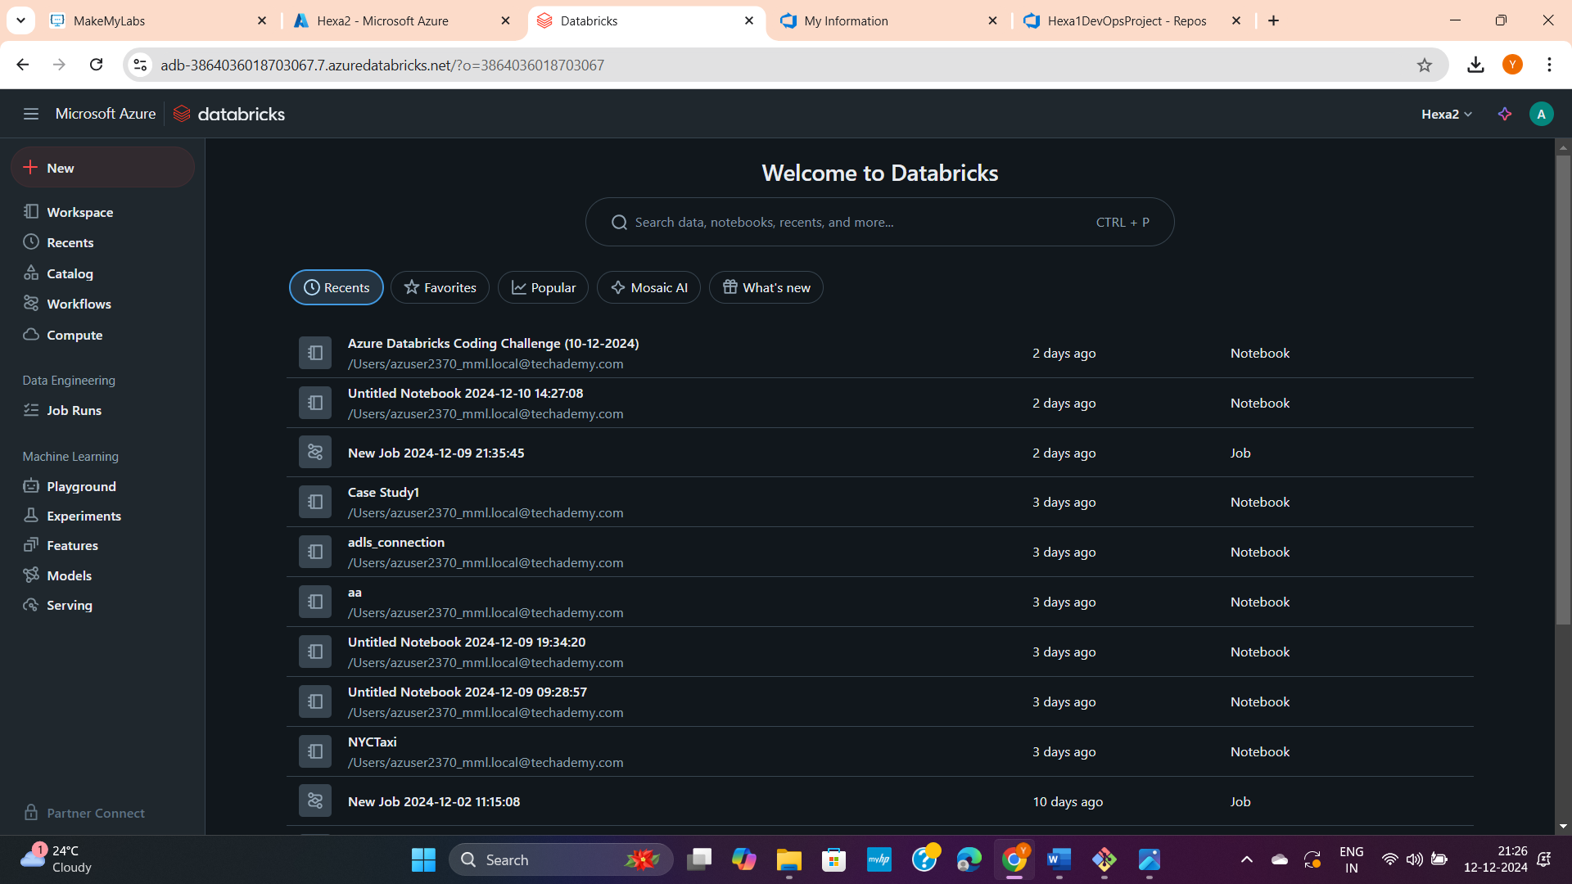

Go to settings

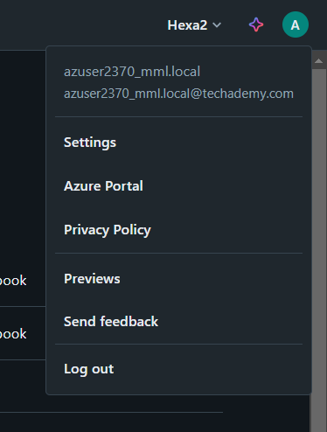

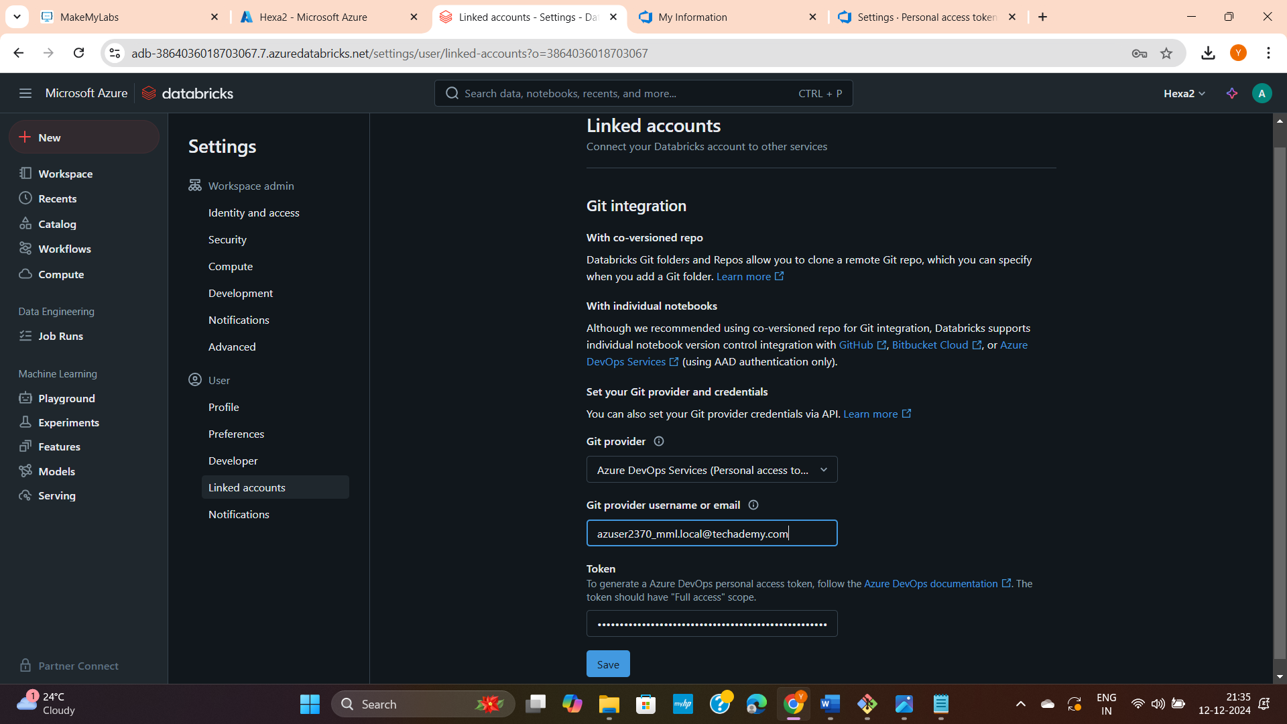

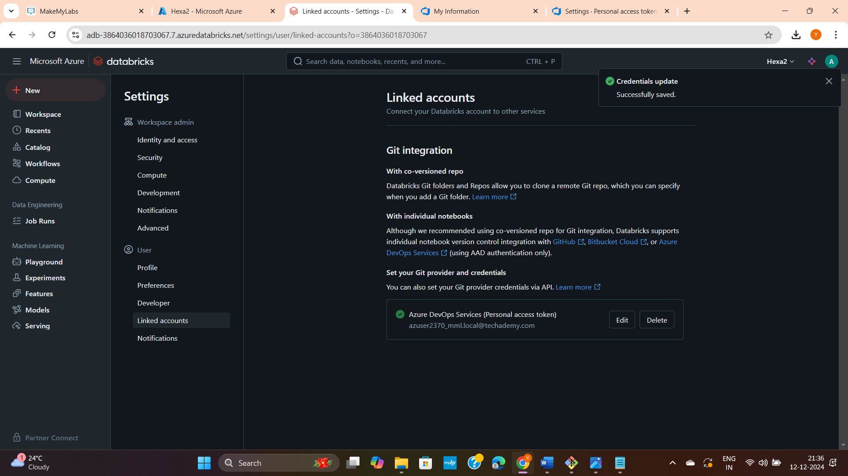

Way 1: (I used. But sub files are not displayed and only directory got displayed)

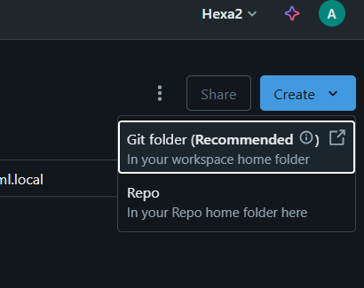

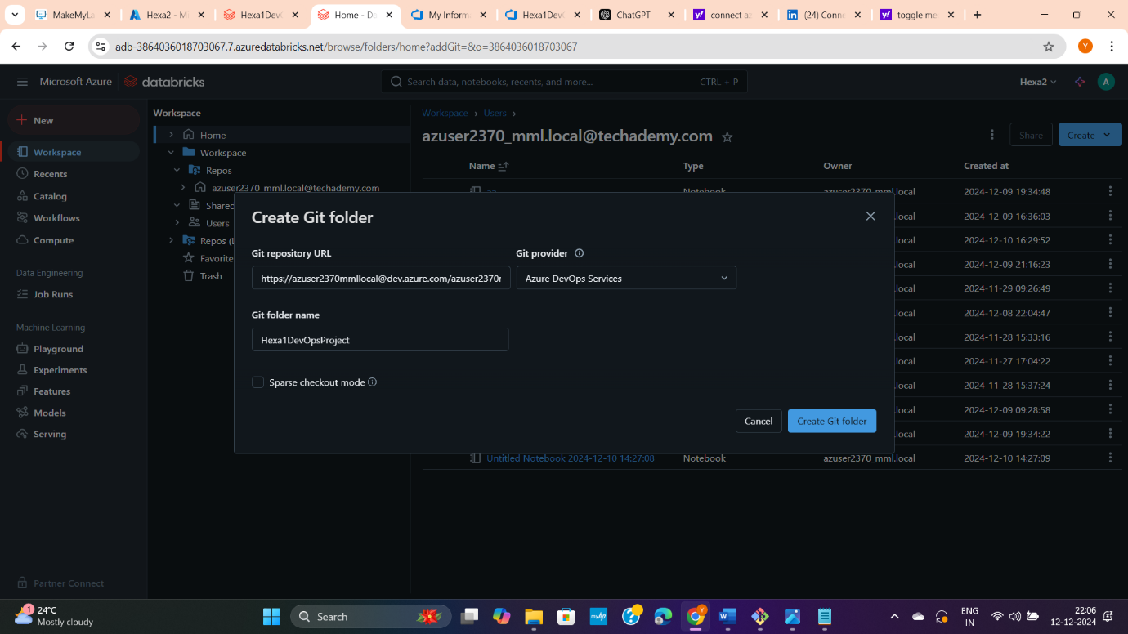

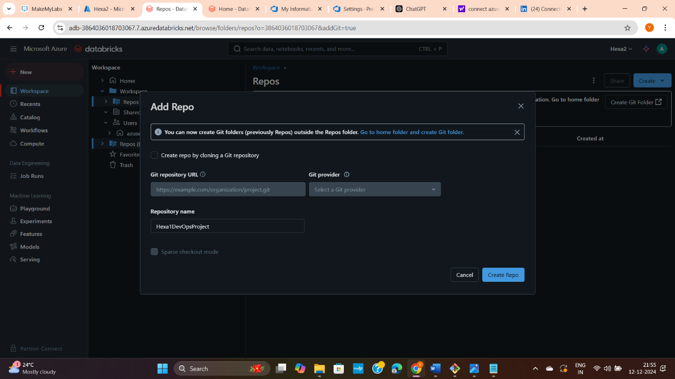

Way 2:

